DWR/DISE Aquatic Ecology Unit

**Informational Guide**

Last Revised: 09/15/2023 (LV)

Version: 1.3

# Yolo Bypass Fish Monitoring Program: Archiving Samples

The YBFMP maintains a large sample archive collection of fish specimens, drift invertebrate samples, zooplankton samples, fish egg and larval samples, and phytoplankton samples. This guide provides details on proper sample storage, sample lifespan, disposal of samples, and the proper way to inventory samples.

# Fish specimens

The objective of the YBFMP’s fish sample archive is to maintain a collection of fish specimens for reference and potential future analyses (specimen condition permitting). Fish are stored for a variety of reasons including CWT extraction, otolith and stomach removal, and genetic analysis. Specimens in the past have provided key information about how salmon and other floodplain-associated species utilize the Yolo Bypass floodplain (e.g., stomach contents). Therefore, in order to continue building the program’s extensive fish sample archive, salmon and other listed species take will be stored indefinitely to ensure a collection of species are available as needed or upon request. The following is a guide for properly labeling, storing, and archiving fish samples collected by the YBFMP or other program collaborators:

## CWT fish:

* Fish that are stored for the intended purpose of CWT extraction are to be stored in the freezer and labeled properly (including study, site, date, species, number of species, and intended procedure (e.g. CWT extraction)). They should be placed in the correct bin (determined by year) and the correct large plastic bag (determined by study/species). Fish are to be processed by the end of the following water year (i.e. fish caught in water year 2019 should be processed no later than the end of water year 2020). **After CWT extraction is complete, fish are to be properly disposed of.** 
  + If, for some reason, the fish heads or whole bodies of CWT extracted fish need to be stored in the freezer for an extended period of time, a **new** external label should be created with an updated status (i.e. “CWT done”), completion date and reason for prolonged storage. An internal label should also be created and placed inside bag for all archive or long-term samples.

## Otolith and stomach removal fish:

* Smelt (i.e. Delta, Long-fin or Wakasagi) that are stored for the intended purpose of otolith or stomach removal are to be stored in the freezer and labeled properly (including **study, site, date, species, number of specimens, and intended procedure**). They should be placed in the correct bin (determined by year) and the correct large plastic bag (determined by study/species). Smelt should be processed by the end of the following water year (i.e. fish caught in water year 2019 should be processed no later than the end of water year 2020). Once smelt have been processed, a **new** external label should be created with an updated completion date and status (i.e. stomachs removed). An internal label should also be created and placed inside bag for all archive or long-term samples. **Processed smelt are then to be stored indefinitely**. If fish samples are to be stored for a specific reason other than the YBFMP’s archived collection, an additional note should be added to the label (i.e. histopathology study).
* Salmon that are stored for the intended purpose of otolith or stomach removal are to be stored in the freezer and labeled properly (including **study, site, date, species, number of specimens, and intended procedure**). They should be placed in the correct bin (determined by year) and the correct large plastic bag (determined by study/species). Salmon should be processed by the end of the following water year (i.e. fish caught in water year 2019 should be processed no later than the end of water year 2020). Once salmon have been processed, a **new** external label should be created with an updated completion date and status (i.e. otoliths removed). An internal label should also be created and placed inside bag.An internal label should also be created and placed inside bag for all archive or long-term samples. **Processed salmon are then to be stored indefinitely**. If fish samples are to be stored for a specific reason other than the YBFMP’s archived collection, an additional note should be added to the label (i.e. Yolo growth study).

## Fish storage for reasons other than CWT, otolith, or stomach removal:

* Fish that are stored for any purpose other than for the removal of CWT’s, otoliths, or stomach should be labeled with the following information:
  + What study the fish is for or apart of
  + Name of owner
  + Date of storage
  + Date to be stored until
  + Type of specimen/sample
  + Number of specimens/samples
  + Reason for storage, if applicable

These fish should be placed in the correct storage bin (determined by year) and the correct large plastic bag (determined by study/species). If the fish are not a part of YBFMP or are only remaining in the freezer for a short period of time, they can be placed in the short-term storage bin rather than the relevant year bin.

Unless otherwise stated for a special study, or with permission from the IEP permitting coordinator regarding alternative storage, Delta Smelt should be stored in glass sample vial in 95% ethanol.

**\*Any fish stored in the freezers with missing or illegible labeling will be removed and properly disposed of.**

## Fish Inventory Documentation:

When fish samples are added for long term storage (i.e. they are for annual archives, they need to be kept longer after processing, etc.) the sample number, all associated information, and freezer location must be added to the standing freezer inventory sheet posted on the outside of the freezer. When appropriate, transfer the written sheet to the “Freezers” tab in the “AEU Sample Inventory and Archive” excel document to record when new samples are added to the collection. [\\cnrastore-des\Yolo Bypass\YB_Inventory\AEU Sample Archiving and Inventory_2022-09.xlsx] remove disposed of samples from the active freezer tab and add it to the “Discarded” tab.

## Proper Sample Labeling:

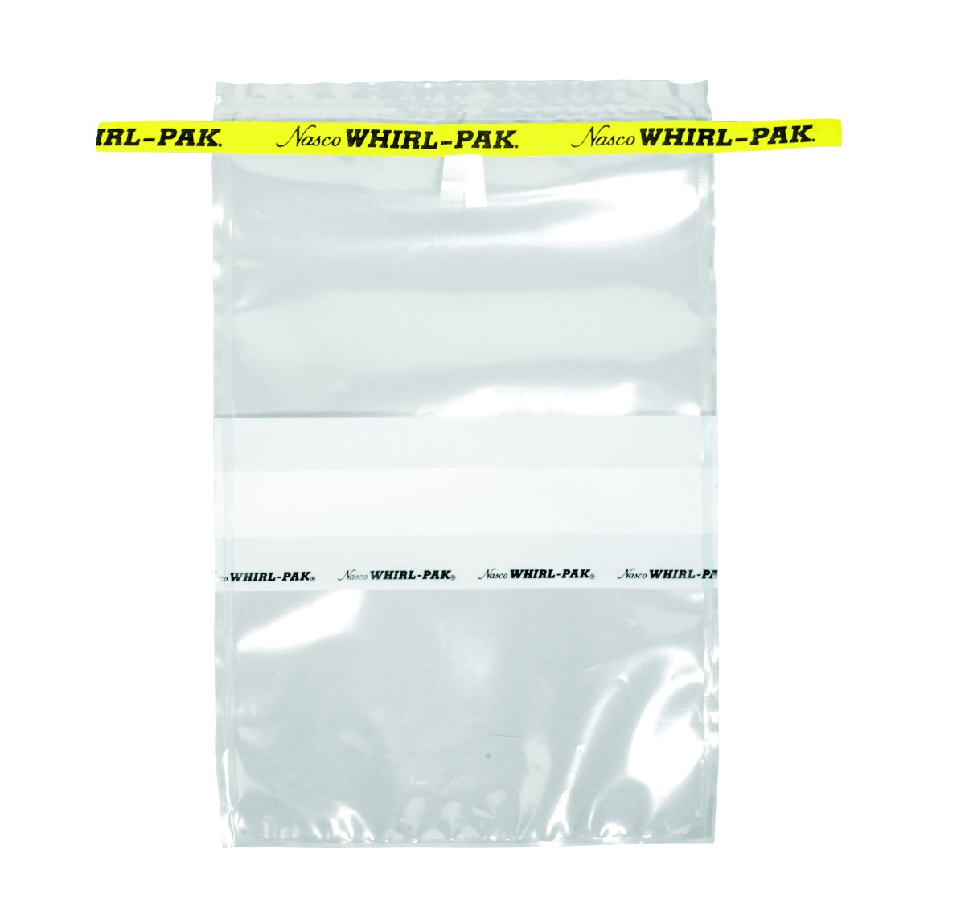

**Study: YBFMP Site: STTD**

**Date: 4/21/2020 6 CHNF-**

**CWT Extraction Craig Stuart**

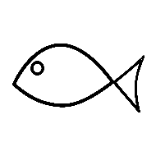

# Lower Trophic Samples

When lower tropic samples are stored after being returned from contractor, they should be grouped by sample type and year, in order to quickly add to the inventory and to find later for disposal.

Before handling, topping off, or disposing of samples, Familiarize yourself with the potential hazards of chemical use. Reference the MSDS for all chemicals listed on the equipment list. These can be found in the MSDS binder located under the remote fume hood or online at [[https://sdsbinderworks.com/]](https://sdsbinderworks.com/)(username: dwr, password: water)

## Drift Invertebrate Samples

The drift invertebrate sample collection for the YBFMP is contracted out to **EcoAnalysts, Inc.** for identification of drift invertebrates from the Sacramento-San Joaquin Delta. Contract language states that, “EcoAnalysts, Inc. will store drift samples for no more than 90 days [post-analysis] and transfer archived samples back to DWR for a suitable storage location.”

### Storage:

Drift invertebrate samples are stored in the AEU chemical storage room cabinets. They are stored in individually labeled glass jars containing 70% ethanol.

### Lifespan:

The recommendation for storage time varies based on how the samples are maintained (Shanda McGraw, EcoAnalysts, Inc.). Based on our low reanalysis rate and limited amount of storage space, the YBFMP stores drift invertebrate samples for up to 5 years. If space is limited, the samples can be kept for a minimum of 3 years before being discarded. All samples must be examined and topped off annually to preserve quality condition.

### Disposal:

When samples have reached the end of their lifespan, they shall be properly disposed of. The disposer must wear personal protective equipment including a lab coat, safety goggles, and gloves. The contents of the sample must be removed with a 250-micron sieve and all of the ethanol must be drained into an ethanol waste container. The contents removed must be left on a tray overnight so that the ethanol can evaporate then can be thrown in the garbage. Glass sample jars must be cleaned with hot soapy water, rinsed three times, and dried, before being stored in the lab cabinets labeled “transfer jars” for reuse.

### Inventory Documentation:

Use the “Drift Invertebrates” tab in the “AEU Sample Inventory and Archive” excel document to record when new samples are added to the collection. Also remove disposed of samples from the active tab and add them to the “Discarded” tab. [YB_Inventory\AEU Sample Archiving and inventory_2022-09.xlsx]

## Ichthyoplankton Samples

The ichthyoplankton sample collection for the YBFMP is contracted out to **EcoAnalysts, Inc.** for identification of ichthyoplankton from the Sacramento-San Joaquin Delta. Contract language states that, “EcoAnalysts, Inc. will store samples for no more than 90 days [post-analysis] and transfer archived samples back to DWR for a suitable storage location.”

### Storage:

Ichthyoplankton samples are stored in the AEU chemical storage room cabinets. They are stored in individually labeled glass jars containing 70% ethanol.

### Lifespan:

Ichthyoplankton samples can be stored for up to 10 years (Shanda McGraw, EcoAnalysts, Inc.). Based on space and ability to keep up the condition of samples, the YBFMP stores samples up to 5 years. If space is limited, the samples can be kept for a minimum of 3 years before being discarded. All samples must be examined and topped off annually to preserve quality condition.

### Disposal:

When samples have reached the end of their lifespan, they shall be properly disposed of. The disposer must wear personal protective equipment including a lab coat, safety goggles, and gloves. The contents of the sample must be removed with a 250-micron sieve and all of the ethanol must be drained into an ethanol waste container. The contents removed must be left on a tray overnight so that the ethanol can evaporate then can be thrown in the garbage. Glass sample jars must be cleaned with hot soapy water, rinsed three times, and dried, before being stored in the lab cabinets labeled “transfer jars” for reuse.

### Inventory Documentation:

Use the “Ichthyoplankton” tab in the “AEU Sample Inventory and Archive” excel document to record when new samples are added to the collection. Also remove disposed of samples from the active tab and add it to the “Discarded” tab.

## Zooplankton Samples

Zooplankton identification is contracted out to **ICF International, Inc**. After samples have been processed and data sent to DWR, ICF will store the samples for no more than 90 days and transfer samples back to DWR.

### Storage:

Zooplankton samples are stored in the AEU chemical storage room cabinets. They are stored in individually labeled glass jars containing 70% ethanol.

### Lifespan:

Zooplankton samples can be stored for 20 years plus, if samples are maintained well and ethanol remains at a high level and at 70% (previous contractor guidance). Based on YBFMP’s low reanalysis rate and limited storage space, zooplankton samples are stored for up to 5 years. If space is limited, the samples can be kept for a minimum of 3 years before being discarded. All samples must be examined and topped off annually to preserve quality condition.

### Disposal:

When samples have reached the end of their lifespan, they shall be properly disposed of. The disposer must wear personal protective equipment including a lab coat, safety goggles, and gloves. The contents of the sample must be removed with either a 106-micron sieve (150-micron net samples) or a 45-micron sieve (50-micron net samples) and all of the ethanol must be drained into an ethanol waste container. The contents removed must be left on a tray overnight so that the ethanol can evaporate then can be thrown in the garbage. Glass sample jars must be cleaned with hot soapy water, rinsed three times, and dried, before being stored in the lab cabinets labeled “transfer jars” for reuse.

### Inventory Documentation:

Use the “Zooplankton” tab in the “AEU Sample Inventory and Archive” excel document to record when new samples are added to the collection. Also remove disposed of samples from the active tab and add it to the “Discarded” tab.

## Phytoplankton Samples

Phytoplankton identification and enumeration is carried out by **BSA Environmental Services, Inc**. After samples have been processed and data sent to DWR, BSA will store the samples for no more than 90 days and transfer samples back to DWR.

### Storage:

Phytoplankton samples are returned in their original amber vial containers with Lugol’s Iodine solution and stored in the AEU warehouse cage.

### Lifespan:

Phytoplankton samples should be stored for 2 years and then discarded.

### Disposal:

When samples have reached the end of their lifespan, they shall be properly disposed of. The disposer should wear easily washable clothing or a lab coat (Lugol’s will stain clothing) and gloves. Phytoplankton samples must be discarded down the sink drain with plenty of water. Sample bottles must be cleaned with soap and water, rinsed three times, and dried before being stored for reuse.

### Inventory Documentation:

Use the “Phytoplankton” tab in the “AEU Sample Inventory and Archive” excel document to record when new samples are added to the collection. Also remove disposed of samples from the active tab and add it to the “Discarded” tab.

# Past edits and collaborators:

[5/28/2020] – [Craig Stuart] – Created the document and added all fish specimen content.

[6/4/2020] – [Amanda Casby] – Made edits to format and added drift invertebrate, zooplankton, phytoplankton, and fish eggs and larvae content.

[7/31/2020] – [Jesse Adams] – Finalization edits for clarity, grammar and accessibility.

[10/8/2021] – [Nicole Kwan] - Updated division and unit names following reorg; added info for storage of Delta Smelt in 95% ethanol (permitting requirement).

[4/4/2022] – [Mallory Bedwell] – changes from SOP to guide. reviewed and edited guide for wording.

[9/1/2023] – [Lisa Vance] – updates to contractors for zooplankton and phytoplankton, updated AES to AEU, and updated storage location for samples after return from contractors.